# **Tableau Script-3**

# **Agenda**

1. **Operations**
   1. Joins
   2. Union
   3. Blending
2. **Advance**
   1. Group by
   2. Window Function
   3. Level of Details(LOD)
3. **Addressing and Partitioning**

* In SQL two merge two tables we use JOINS, right?
  + We find common columns to join the table
* Now suppose you have two datasets A and B in two different databases of Oracle and MYSQL
  + Can you connect them in normal SQL?
  + No, we can’t even if we have a common column. For this, we use software like **Altrix, Informtica, Dataiku DSS,** etc.
* To join data from two different Data Sources, we use **blending** in tableau.
* **Union** mean just appending data.

**Dataset:** sample superstore

**Note**: Duplicates have been removed from the **Return** sheet. Use **remove duplicates** in excel to do so.

**Q. Revenue/Profit loss after returns.**

* Revenue/profit is in the Orders table and return is in the returns table. So in which column would we join both tables?
  + At glance, it would look like the **OrderID column**
* Now if we observed closely **OrderID** in the orders table is not unique. This table is unique at OrderID & Product name.
* If we have not removed duplicates in the **return table**, then there would **multiple duplicate rows** after joining them.
* Let’s see how we perform JOINs in Tableau
* After dragging Orders, double click on it, and a rectangular box will appear and then drag the return table.
* Automatically it is taking **inner join**, which means we will have a dataset where only the return has been placed.
* So I will use **left join** so that I have data for all orders along with returned ones.



* Preview our dataset now
* Null values because no returned is placed for these orders.

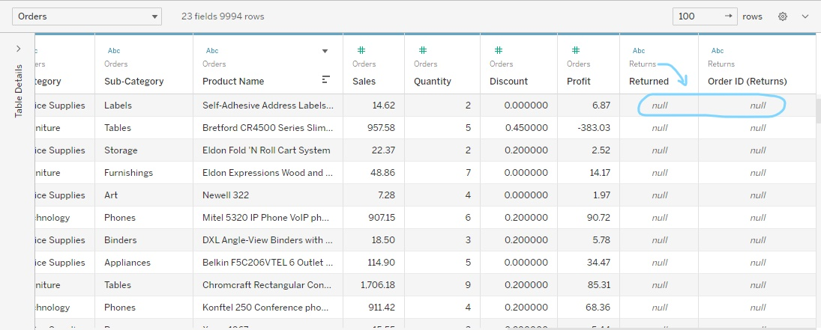

* For these orderID we have returned values as not null.
* You can also observe that all these 3 ordersID are same but the ProductName is different. That is what makes each row unique.



* Getting back to our question now, we want revenue/profit loss after returns.
* Let's check sales and profit at the category level



* How do we see sales and profit for returned orders?
  + By using filter
* Also, we changed the name of the **null filter** to NO to give it more understanding.



* Tableau gives us some other functionality using calculated fields, by which we can get sales and profit for returned and non-returned orders.
* Let’s see how it is done using **if-else** in tableau.



* Let’s do the same thing when returned is null.



* Let's drag and drop our fields to see if they reflect sales acc to our fields



* Till now we saw operations after Joins.
* Now explore how UNION is done.
* Let’s you were working with a dataset in 2022, now new data with the same fields of 2023 comes up. So using UNION you just need to append it.



* Now we gonna see how data from different sources is connected
* Dataset1: [World_CO2](https://docs.google.com/spreadsheets/d/1sN7pp7V2YnWC4UzwW6JKgX30o1_yyuT9/edit#gid=1278600190) and Dataset2: [Olympic_Medal](https://docs.google.com/spreadsheets/d/1ulYUouBGOSaAr3AIUDjVOC8vKwc6s_sp/edit#gid=1544677764)



* We are going to see how blending is done.
* The main difference between the two is when the aggregation is performed. **A join combines the data and then aggregates.** **A blend aggregates and then combines the data.**



* How to edit blend relation on columns?



**Observation:**

1. Once we drag and drop a field in the sheet after **edit blend relation**, we see a🔗 symbol that signifies **blending.**

* Let’s see how we analyze after setting up blend relation b/w two different data sources.
* For each country I want to see CO2 per capita and the Total no of medals



**Observation:**

1. For the US we are seeing **null values** in the **total no of medals**.
2. For this we changed the **alias** of **USA** to the **United States**.

**Q2.** Can you show the % contribution of every sub-category for its category?

**E.g**

* For category A, there are x,y, and z sub-categories.
* For each sub-category, their contribution is given
* Find their % contribution.
* Let’s break it down and get the **sales for each category**.
* So basically we will be creating field by applying groupby in tableau.



* Now what we want is % contribution, we will do this by creating another calculated filed



* Suppose we have duplicates in our data
* So by using LOD, how do you think we can remove duplicates?

|  | Sales |  |  |
| --- | --- | --- | --- |
| A |  |  |  |
| A |  |  |  |
| A |  |  |  |
| A |  |  |  |

* We can LOD group by below
  + {Fixed [category][product]: Sum(sales)}
  + Sum(sales) will give 440, which is what we do not want.
  + So instead Sum(sales), we can do Max(sales) or Min(sales)

**Q3.How do you perform cumulative sum on sales?**

* + Explain to students the concept if they don’t know
  + Do a little formatting on numerical fields, like removing decimals, and adding currency



* When there is a partition from the 5th row, we can still see the sum of all the rows is equal to the blue box. But that is what we don't want. We want a cumulative sum for each partition.

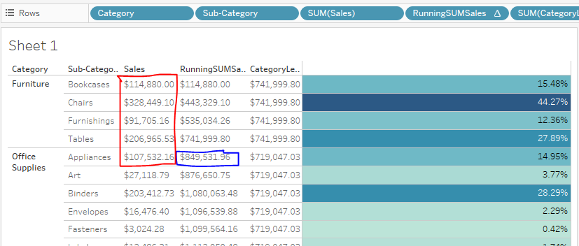

* Many students might say that we can use **Fixed,** which is group by in tableau but that will give us an **error**
* The error is that Tableau doesn’t allow us **to use Table cal in LOD calculation** like Fixed.



* For this we introduce **Addressing and Partition** in tableau
* Let’s see % the percentage of the total given below
* So we saw % of the total is calculated across the table not along/down the table



* So how we actually know % of total is along or across the table
* We will see this with **INDEX**
* So the numbering in the table is reflecting the calculation flow



* Let’s observe the different flow of calculations



* Changing flow of % of total calculation down the table



* The flow of the calculation is going down the table till the end of it but what we want is for each partition/category.
* So how do we do it?



* Let’s go back to our problem of **RunningSumSales** and solve it using **Address and partitioning** that we learned now.
* Here instead of selecting only **Pane(down)**, we choose **specific dimension,** which lets us do running sum at the sub-category level.

